Que 1.

-20,000 = 60% success -100,000 = 80% sucesss
= 20% fail +$20,000 = -$753,418.47
40% fail $0 = $20,000

NPV | Joint Probability | Expected NPV
881718.5 | 0.24 | 194,812.44
-185952 | 0.24 | $-44628.50
-376,709.00 | 0.12 | $-45,205.10
-20,000.00 | 0.4 | $-8,000

Expected NPV = $117,778.79
STD Deviation = $445060
Coefficient of variation = expected NPV/ std. deviation =3.78

Que 2.

Initial Cash flow
New machine Purchase price | $700,000
New machine Purchase price | $700,000
Less: Salvage value old machine | $(135,000)
less: savings due to loss on sale
($450,000-$135,000)× 0.35 | $(110,250)
Cash outflow for new machine | $454,750

Incremental Depreciation
Year | Depreciation % | Depreciation basis | Depreciation allowance new | Depreciation allowance old | Change in old dep.
1 | 20.00% | $700,000 | $140,000 | $90,000 | $50,000
2 | 32.00% | $700,000 | $224,000 | $90,000 | $134,000
3 | 19.20% | $700,000 | $134,400 | $90,000 | $44,400
4 | 11.52% | $700,000 | $80,640 | $90,000 | $9,360
5 | 11.52% | $700,000 | $80,640 | $90,000 | $9,360

Year | Calculation | Incremental cash flows
Calculation= {(annual savings - Incremental depreciation) - Tax} + incremental depreciation
1 | {(190,000-50,000)-35%} + 50,000 | $141,000
2 | {(190,000- 134,000) - 35%} + 134,000 | $170,400
3 | {(190,000 - $44,400)- 35%} + 44,400 | $139,300
4 | {(190,000- $9,360)- 35%} + 9,360 | $126,776
5 | {(190,000 -$9,360) - 35%} + 9,360 | $126,776

d
The company should purchase a new machine, it has a positive Net Present Value
Year | Cash flows | PV Factor @15% | PV of cash flows
 |  | 1/(1+15%)˄n
0 | $(454,750) | 1 | $(454,750)
1 | {($190,000- $140,000)- 35%}+ 140,000 | 0.8696 | $150,000
2 | {($190,000 - $224,000)- nil} + 224,000 | 0.7561 | $169,376
3 | {($190,000- $134,400)-35%)} + 134,400 | 0.6575 | $112,132
4 | {($190,000- $80,640) - 35%} +80,640 | 0.5718 | $86,749
5 | {($190,000- $80,640) - 35%} +80,640 | 0.5718 | $86,749

When the expected life of machine goes down, the cash flows decrease which results to a negative net present value.
An increase in the WACC indicates a decrease in the cash flows, which results to a negative net present value.

Question 3

Everly Equipment
Depreciaion per year old machine | $7,500
Book value =75000-(5×7500) | $37,500
Sales price | $35,000
Loss on sale | $2,500
Cost of new machine | $140,000
Sale value of old machine | $35,000
 | $175,000

Year | Depreciation | Cost | Old | Change
1 | 33.33% | 46,662 | 7,500 | 39,162
2 | 44.45% | 62,230 | 7500 | 54,730
3 | 14.81% | 20,734 | 7500 | 13,234
4 | 7.41% | 10,374 | 7500 | 2,874
5 |  |  | 7500 | -7,500
 | Year 0 = $175,000

Year | Incremental net cash flows
 | savings(1-t) + change in depreciation × t
1 | 25000× (1-0.35) +39162 ×0.35 | $29,956.70
2 | 25,000 × (1-0.35) + 54,730 × 0.35 | $35,405.50
3 | 25,000 × (1-0.35) + 13234 × 0.35 | $20,881.90
4 | 25,000 × (1-0.35) + 2,874 × 0.35 | $17,255.90
5 | 25,000 × (1-0.35) -7,500 × 0.35 | $13,625

 |  | 1/(1+r)˄n
Year | Cash flow | PV factor @15% | NPV
0 | $175,000 | 1 | 175,000
1 | $29,956.7 | 0.869565 | 26,049.30
2 | $35,405.5 | 0.7561437 | 26,771.65
3 | $20,881.9 | 0.6575162 | 13,730.19
4 | $17,255.9 | 0.571753 | 9,866.11
5 | $13,625 | 0.497177 | 6,774.04

Que 4
Answers Using excel
Part 1
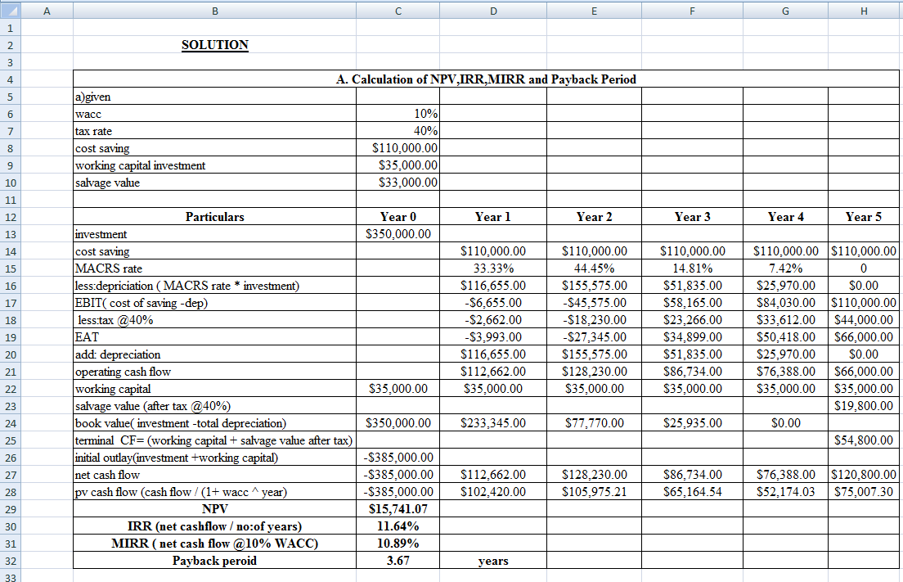
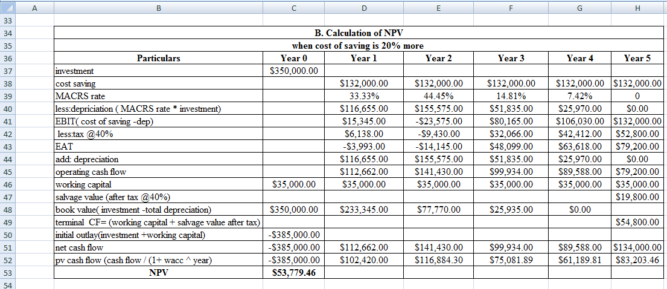
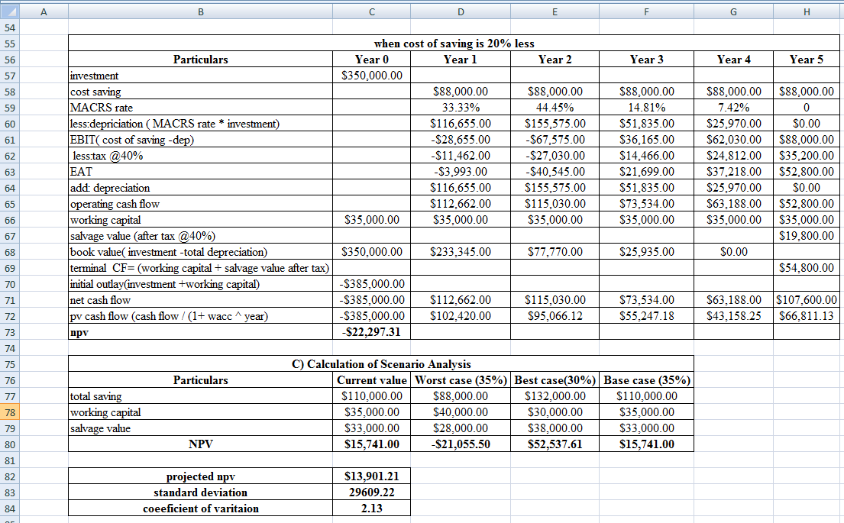

Que 5.

Net cash cost
Price = $80,000
Modification = $14,500
Change in NWC = $4,600
$99,100

. The operating cash flows follow:
The after-tax cost savings is $23,800(1 - T) = $23,800(0.6) = $14,280
Year 1 Year 2 Year 3
$14,280, $14,280, $14,280
Price + Modification = $80,000 + $14,500 = $94,500
Rates, Allowance Percentage
0.3333 × $94,500 =$31,497
0.4445 × $94,500=$42,005
0.1481 × $94,500= $13,995
Depreciation shield = 40% by the Allowance percentage.
0.4 × $31,497 = $12,599
0.4 × $42,005 = $16,802
0.4 × $13,995 = $5,598
Depreciation shield for year 1, year 2, year 3; $12,599, $16,802, $5,598

Net cash flow
Year 1 = $14,500 + $12,599 = $27,099
Year 2 = $14,500 + $16,802 = $31,302
Year 3 = $14,500 + $5,598 = $ 20,098

Book value = $94,500 × (0.0741) =$7,002
Tax on salvage = ($31,200 - $7,002) × 0.4 = $9,679
Net working Capital = $4,600
Net cash flow = $31,200 - $9,679 = $21,521+ $4,600 = $26,121
$26,121

Year Net Cash Flow
0 ($94,500)
1 $27,099
2 $31,302
3 $46,219
Cash inflow – cash outflow
1/ (1+r)^{n}
$30,080 + $37,875 + $34,725 – $94,500
$102,680 – $94,500 = $8,180
The project has an NPV of $8,180. Thus, it should be accepted.

